SAFETY DATA SHEET
Professional Fabric Conditioner

SECTION 1. IDENTIFICATION OF THE SUBSTANCE / PREPARATION AND OF THE COMPANY / UNDERTAKING

1.1 Product Name | Professional Fabric Conditioner
1.2 Other Names  SDS No | Professional Fabric Conditioner  C2/276-CLP Rev Date: 17th November 2017 Rev No: 2
1.3 Application | Laundry Aftercare Application
1.4 Supplier  1.5 Email | AUK Hygiene Ltd
7 Cavalier Road
Heathfield industrial Estate
Newton Abbot
Devon
 | sales@auk-group.com
Number | Mon to Fri 8.30am to 5.00pm - 01626 355177
SECTION 2. HAZARD IDENT | IFICATION
Classification (EC12 | 72/2008)  None
2.1 Signal Word
2.1 Classification | Physical: Not classified  Health: Not classified
 | Environmental Not classified
Hazard  Statements | Not classified
Precautionary  Statements | P102 Keep out  P301 + 312 If S | so | of reach of children  wallowed: Call a poison centre or doctor if you feel unwell.  If in eyes: rinse cautiously with water for several minutes. Remove contact le . Continue rinsing |  |  |  |  | nses, if present
 | P305+351+338
 | and easy to do
2.2 Labelling | None
2.3 Other Hazards | None noted

SECTION 3. COMPOSITION / INFORMATION ON INGREDIENTS
3.2 Mixture
Product |  | EC (EINECS No. | CAS-No. | %
Alkyl Ester Ammonium |  | 295-344-3 | 91995-81-2 | <5
Classification (EC 1272/2008)
Physical: Not Classified.
Health: Not Classified.
Environmental: Not Classified.
Product |  | EC (EINECS No. | CAS-No. | %
Propan-2-OL |  | 200-661-7 | 67-63-0 | <1
Classification (EC 1272/2008)
Physical: Flam Liq. 2 – H225.
Health: Eye irrit. 2 – H319, STOT Single 3 – H336.
Environmental: Not Classified.
Product |  | EC (EINECS No. | CAS-No. | %
Parfum' |  | N/a | N/a | <1
Classification (EC 1272/2008)
Physical: Not Classified.
Health: Skin Corr 2 – H315, Eye Irrit. 2 – H319 Skin Sen. 1 – H317. Environmental: Aquatic Chronic 2 – H411.
For the full text of the H-statements mentioned in this section, see section 16.
SECTION 4. FIRST -AID MEASURES
4.1 Description of First Aid Measures
Inhalation
Ingestion | Move exposed person to fresh air. Get medical attention if discomfort continues
Skin Contact | Do Not Induce Vomiting! Immediately rinse mouth and drink plenty of water Get medical advice  Remove contaminated clothing immediately and wash with soap and water. Get medical attention if any
 | discomfort continues
Eye Contact | Immediately flush with plenty of water for up to 15 minutes. Remove contact lenses if safe and easy to do so, open eyes wide apart. Get medical attention immediately. Continue to rinse.
4.2 Most Important Sym | ptoms and effects, both acute and delayed
General Information | Symptoms described are dependent upon the concentration and exposure time
Inhalation | Possible irritation of throat, nose & airway
Ingestion | May cause discomfort if swallowed
Skin Contact | May cause skin Irritation
Eye Contact
4.3 Indication of immedi
 | Possible eye irritation ate medical attention and special treatment needed if necessary
SECTION 5. FIRE-FIGHTING MEASURES
5.1 Suitable Extinguishing Media Use:
The preparation is not readily flammable, use fire-extinguishing media suitable for surrounding materials
5.2 Specific Hazard arising from the chemical
When heated in the case of fire, harmful or toxic gases may be produced
5.3 Special protective actions for fire fighters
Self contained breathing apparatus and full protective clothing must be worn

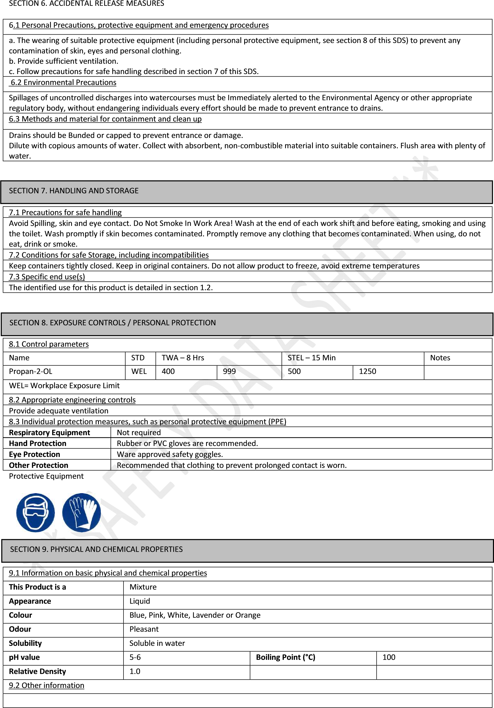

SECTION 10. STABILITY AND REACTIVITY
10.1 Reactivity
None known
10.2 Chemical stability
Stable under normal conditions and use.
10.3 Possibility of hazardous reactions
No specific reactivity hazards associated with this product.
10.4 Conditions to avoid
Avoid excessive heat for prolonged periods of time. Do Not allow to freeze
10.5 Incompatible materials
Strong oxidising substances
10.6 Hazardous decomposition products
Oxides of: Carbon
SECTION 11. TOXICOLOGICAL INFORMATION
11.1 Information on toxicological effects
Toxicological information
We have not carried out any animal testing; therefore we have no toxicological data specifically for this product. The toxicological data,
where provided by the raw material manufacture, can be made available on request.

SECTION 12. ECOLOGICAL INFORMATION
12.1 Toxicity
We have not carried out any Aquatic testing; therefore we have no Aquatic Toxicity Data specifically for this product. The Aquatic Toxicity data, where provided by the raw material manufacturer for the ingredients with aquatic toxicity can be provided on request
12.2 Persistence and degradability
Degradability: the products used in this preparation are designed for disposal via normal foul water disposal methods
12.3 Bioaccumulative potential
This preparation does not contain any substance that is expected to be bioaccumlating
12.4 Mobility in soil
The product is soluble in water
12.5 Results of PBT and vPvB
This preparation does not contain and PBT or vPvB substances
12.6 Other adverse effects
None Known
SECTION 13. DISPOSAL CONSIDERATIONS
13.1 Waste treatment methods
The preparation is designed for disposal via foul drain after use. Large volumes to be treated as controlled waste. Disposal to licensed
waste disposal site in accordance with local waste disposal authority. Clean used container and recycle.
SECTION 14. TRANSPORT INFORMATION

This product is not classified as hazardous for transport, as per IATA, ADR & IMDG.

SECTION 15. REGULATORY INFORMATION

15.1 Safety, health and environmental regulations/legislation specific to the substance or mixture
Guidance notes: Workplace Exposure Limits EH40
EU Legislation: Safety Data sheets prepared in accordance with REACH Commission Regulation (EU) No 453/2010 Packaging & Labelling of dangerous preparations. Ingredients are listed with classification under GHS / CLP – Regulation (EC) No 1272/2008 classification, ADR 2013
15.2 Chemical Safety Assessment
Not applicable this product is a mixture

SECTION 16. OTHER INFORMATION
REV. No. REPL. SDS | 2/1
Generated | 17th November 2017 replaces v1 13th March 2015
SDS No. | C2/276-CLP
SDS Status | Ok
Approved | 17th November 2017
Notes | This information relates only to the specific material designed and may not be valid for such material used in combination with any other materials or in any process. Such information is to the best of the company’s knowledge and belief, accurate and reliable as of date indicated. However, no warranty, guarantee or representation is made as to its accuracy, reliability or completeness. It is the user’s responsibility to satisfy himself as to the suitability of such information for his own particular use.
Hazard statements in full | H225 – Highly flammable liquid and vapours  H315 – Causes skin irritation  H317 – May cause an allergic skin reaction  H319 – Causes serious eye irritation  H336 – May cause drowsiness or dizziness  H411 – Toxic to aquatic life with long lasting effects
Supplementary  P- Statements | None
 | END of SDS

